PROGRAMMABLE CLUSTER HEADEND
FRPRO LIGHT HD
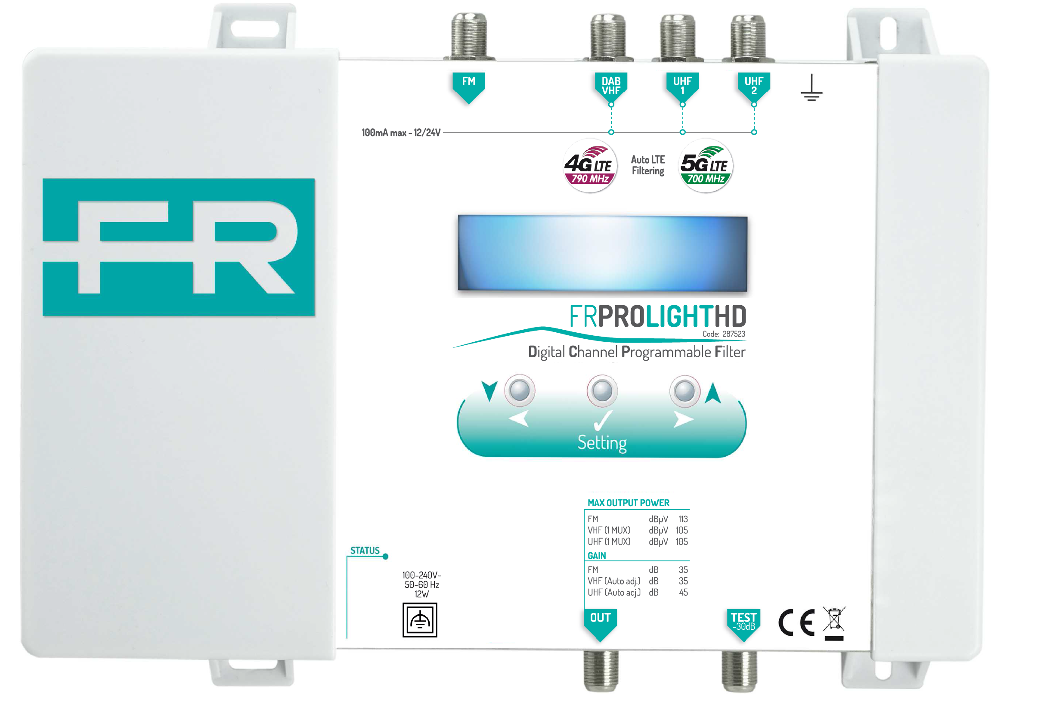
OPERATING INSTRUCTIONS
It is possible to download the FRPRO LIGHT HD manual on the relative product’s page on www.fracarro.com web site
PRODUCT DESCRIPTION
The Fracarro FRPRO LIGHT HD is an high selective programmable compact headend for filter, convert and amplify the VHF/UHF Digital Terrestrial channels as well as mix the FM signal. The headend is a complete Digital Channel Processor that can be used on small, medium or high installation plants as well as in hospitality environments.

- Can process and convert more than 50 independent RF channels with very high selectivity on adjacent multiplexes
- AGC automatic control circuit on all individual VHF and UHF input multiplexes
- Isofrequency or converted channel filtering for every multiplex coming from VHF or UHF input.
- Security code available for avoid incidental settings
- 1 FM input, 1 VHF+DAB input and 2 independent UHF inputs; with selectable 12-24 V remote power on VHF and UHF inputs

PRODUCT INSTALLATION
- Connect the device to the grounding electrode of the antenna system and fix the FRPRO LIGHT HD in vertical position to guarantee the correct ventilation and heat dissipation.
- Connect the power cord to the power supply socket and check the STATUS LED for DC power presence.
- Connect FM, VHF and UHF aerial’s coaxial cables to the FRPRO LIGHT HD headend.
- Connect the RF output coaxial cable to the RF coaxial distribution network.
- If necessary, connect a field meter to the -30dB test port to check the quality signal.
- Configure the device using the three settings buttons available on the top of the FRPRO LIGHT HD headend; press the confirm button for two seconds to access to the main menu and use the left/down or right/up arrows to scroll the sub-menu.

If necessary, the power adapter can easily be replaced, without unmount the product, by open the top left plastic cover; please refer to the Safety Warnings chapter before proceed.

FACTORY SETUP: before starting the configuration, it is advised to set the correct VHF and UHF frequency plan.
- Power off the device,
- Push the confirm button and keep it pushing while you turn-on the FRPRO LIGHT HD.
- Release the button when RESET FINISHED message is shown on display.
- To activate the correct frequency plan select the REGION where the headend is situated and save with the confirm button; Europe (EU) is the default setting.

HEADEND CONFIGURATION
- Power up the FRPRO LIGHT HD by using the 220V power cord included in the package; the headend will need approximately 5 seconds to initialize itself. The configuration can be performed by using the three settings buttons and the display available on the top front.
- Press the confirm button for two seconds to access the different menus or for confirm the selection; scroll all the menu by using left/down or right/up arrows for move through the different settings.
inPUT CONFIGURATION
- Select INPUT FM to setup the desired FM input signal gain.
- Select INPUT VHF, INPUT UHF 1 o INPUT UHF 2 to enter the VHF/UHF input settings.
- Set 12V or 24V on DC if it is necessary to insert the power supply to feed the external must amplifiers; 100mA is the total available current for VHF and UHF inputs; on advanced settings it is possible to set 12V or 24V.
- Select ADD CHANNEL to add the RF channel on the list of the managed filtered multiplexers by the relative input; to delete the unwanted RF channel, move on the position of the channel by using left/down or right/up arrows buttons and press the confirm button for 3 seconds until CHANNEL DELETED message is shown on the display. Up to 5 channels can be added and converted at once; first select the channels you want to add, then you can convert them. For example:
  - To add CH5 and convert to CH6, select as follows: 5: 5 -> 6: 6
  - To add CH21-22-23 and convert to CH31-32-33, select as follows: 21:23 -> 31:33

For the best performances, it’s recommended to add and process only single channels (ADD 1 CHANNEL), unless you need to process a lot of channels.

OUTPUT CONFIGURATION
- By selecting OUTPUT and LEVEL menu it is possible to define the total RF output level from 85dBµV to 105dBµV, depending on the total multiplexes amount managed by the headend, 95dBµV is the default level.
- By selecting SLOPE it is possible to set the slope from 0dB to -9dB, between the VHF and latest UHF channel, 0dB is the default value.

ADVANCED SETTINGS: select ADVANCED menu to:
- LANG: set the language (English, Italian, French or Spanish).
- REGION: read the channel plan configured on factory setup procedure.
- DC VOLTAGE: set 12V or 24V remote power available on VHF and UHF inputs.
- AUTO CH: it suppresses noise when a channel stops broadcasting, to avoid the MER affect of neighbouring channels.
- FILTER: set the following filtering characteristics:
  - BEST MER: best quality thanks to a larger filtering; it is not suitable for adjacent channel distribution.
  - OPTIMAL: default value, best trade off between large filtering and high selectivity.
  - SHARP: best selectivity tanks to a thinner filtering, suitable to distribute adjacent channels.
- FW VERSION and SERIAL NUMBER: to read firmware version and product serial number.
SW version and product updates could modify this menu structure.

Select EXIT menu to exit and protect the headend, if it is necessary, setting a lock code with LOCK menu.

TECHNICAL SPECIFICATIONS
Fracarro code |  | 287523
Inputs
Input number |  | 4 (FM, VHF+DAB, UHF 1 e UHF 2)
Bandwidth | MHz | FM: 88-108; VHF: 174-240; UHF: 470-862
AGC range | dBµV | FM: 37-77; VHF: 45-109; UHF: 45-109
LTE filtering | MHz | Automatic selection: 694, 790 or disabled
Outputs
Output number |  | 1, Test (-30dB)
Maximum level | dBµV | FM: 113 (60dB/IM3); VHF: 105; UHF: 105 (for 15 transp.)
Level adjustment | dB | 20
Gain (Adjustment) | dB | FM: 35 (20); VHF: 35 (auto AGC); UHF: 45 (auto AGC)
Slope adjustment | dB | 9
Selectivity | dB@1MHz | 35
Typical MER | dB | VHF: 35; UHF: 35
General characteristics
Mains voltage | V, Hz | 100-240, 50/60
Consumption | W | 12
Remote power | V, mA | 12 or 24, 100 total (for the 3 inputs VHF, UHF 1 and UHF 2)
Dimensions (l x h x w) | mm | 217 x 165 x 59
Operating temperature | °C | -5 to 50
Weight | Kg | 0,8
The technical data are nominal values and refer to an operating temperature of 25° C, they may vary without notice.

SAFETY WARNINGS
The product must only be installed by qualified persons, according to the local safety standards and regulations. Fracarro Radioindustrie is free from all civil and criminal responsibilities due to breaches of the current legislation derived from the improper use of the product by the installer, user or third parties. The product must be used in full compliance with the instructions given in this manual in order to protect the operator against all possible injuries and the product from being damaged. Don’t open the product case: components under dangerous
voltage may be accessible when the case is opened.

Installation warnings
- The product must not be exposed to any dripping or splashing and thus it should be installed indoors and in a dry location.
- Humidity and condensation could damage the product. In case of condensation, wait until the product is dry before using it.
- Handle the product carefully. Impacts can damage the product.
- Leave enough space around the product to ensure sufficient ventilation.
- Excessive temperatures and/or an overheating may affect the performance and the life of the product.
- Don’t install the product above or near any heat sources, in dusty places or where it might come into contact with corrosive substances..
- In the event that the unit is fixed to the wall, use the proper screw anchors suitable to the characteristics of the fixing support. The wall and the anchoring system must be able to support at least 4 times the weight of the unit.

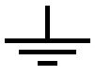
Warning: to avoid injury, this appliance must be secured to the wall depending on the installation instructions. For "PERMANENTLY INSTALLED APPLIANCES", an easily accessible cutting device must be added to the exterior of the appliance; for "APPLIANCES WITH A POWER PLUG", the socket must be installed close to the appliance and easily accessible. The product must be connected to the grounding electrode of the antenna system in compliance with standard EN 60728-11. The screw provided for this purpose is marked with the symbol

It is recommended to comply with the provisions of the standard EN60728-11 and to connect this screw to the main earth node of the plant (do not connect to intermediate points).

Earth screw symbol

Class II symbol
General warnings: In the event of a malfunctioning, do not try to fix the product as the guarantee would be invalidated. Only use the power supply supplied with the product. Although the information given in this manual has been prepared carefully and thoughtfully, Fracarro Radioindustrie S.r.l. reserves the right to modify it without notice and to improve and/or modify the product described in this manual. See the website www.fracarro.com to have information relevant to the technical support and product guarantee.
The recycling of materials will help to conserve natural resources.

CONFORMITY TO EUROPEAN LAWS
Fracarro declares that the product complies with EU Directive 2014/53 and 2011/65/UE. The full text of the EU Declaration of Conformity is available on the following website ce.fracarro.com.
USER’S INFORMATION
Disposal of Old Electrical & Electronic Equipment
Applicable in the European Union and other European countries with separate collection system
 | This symbol on the product or on its packaging indicates that this product shall not be treated as household waste. Instead it shall be handed over to the applicable collection point for the recycling of electrical and electronic equipment. By ensuring this product is disposed of correctly, you will help prevent potential negative consequences for the environment and human health, which could otherwise be caused by inappropriate waste handling of this product. The recycling of materials will help to conserve natural resources. For more detailed information about recycling of this product, please contact your local city office, your household waste disposal service or the shop where you purchased the product.

Guaranteed by Fracarro Radioindustrie SRL Via Cazzaro n. 3, 31033 Castelfranco Veneto (Tv) – Italy  Fracarro Radioindustrie SRL: Via Cazzaro n.3 - 31033 Castelfranco Veneto (TV) - ITALIA - Tel: +39 0423 7361 - Fax: +39 0423 736220  Fracarro France S.A.S.: 7/14 rue du Fossé Blanc Bâtiment C1 - 92622 Gennevilliers Cedex - FRANCE Tel: +33 1 47283400 - Fax: +33 1 47283421  Fracarro (UK) – Ltd: Unit A, Ibex House, Keller Close, Kiln Farm, Milton Keynes MK11 3LL UK - Tel: +44(0)1908 571571 - Fax: +44(0)1908 571570  www.fracarro.com - info@fracarro.com - supportotecnico@fracarro.com - chat whatsapp +39 335 7762667 | FRPRO LIGHT HD  10-05-2019 - rev.02

